- Random diceValue exсludes Spade win/loss ratio varies
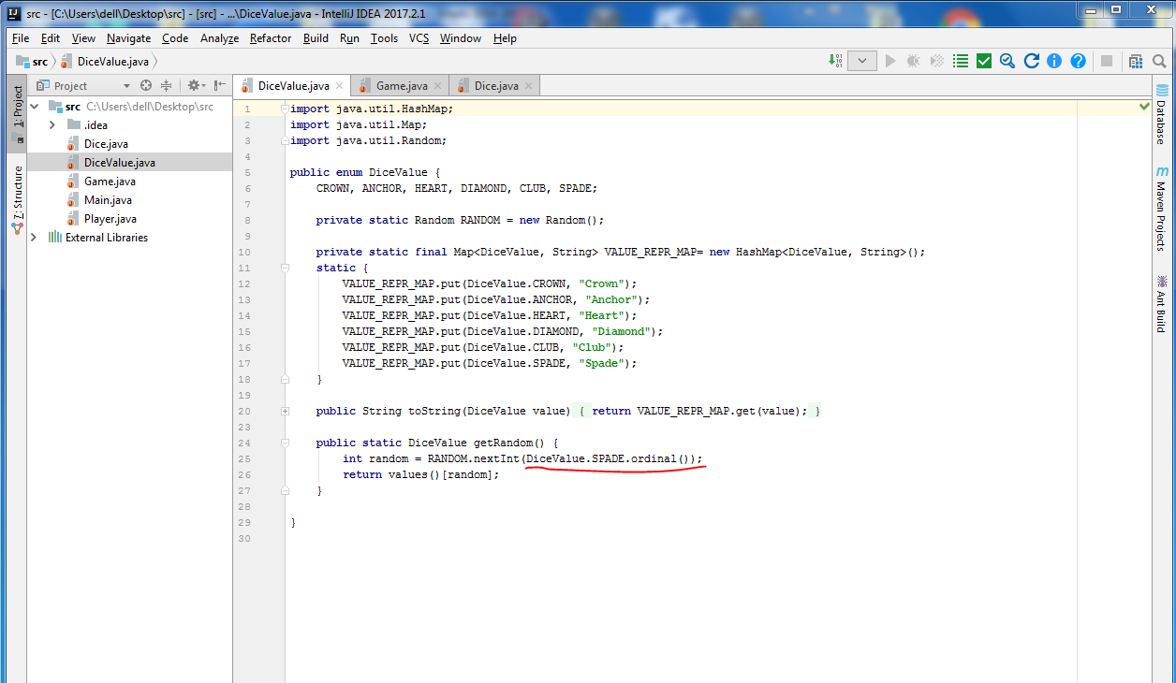

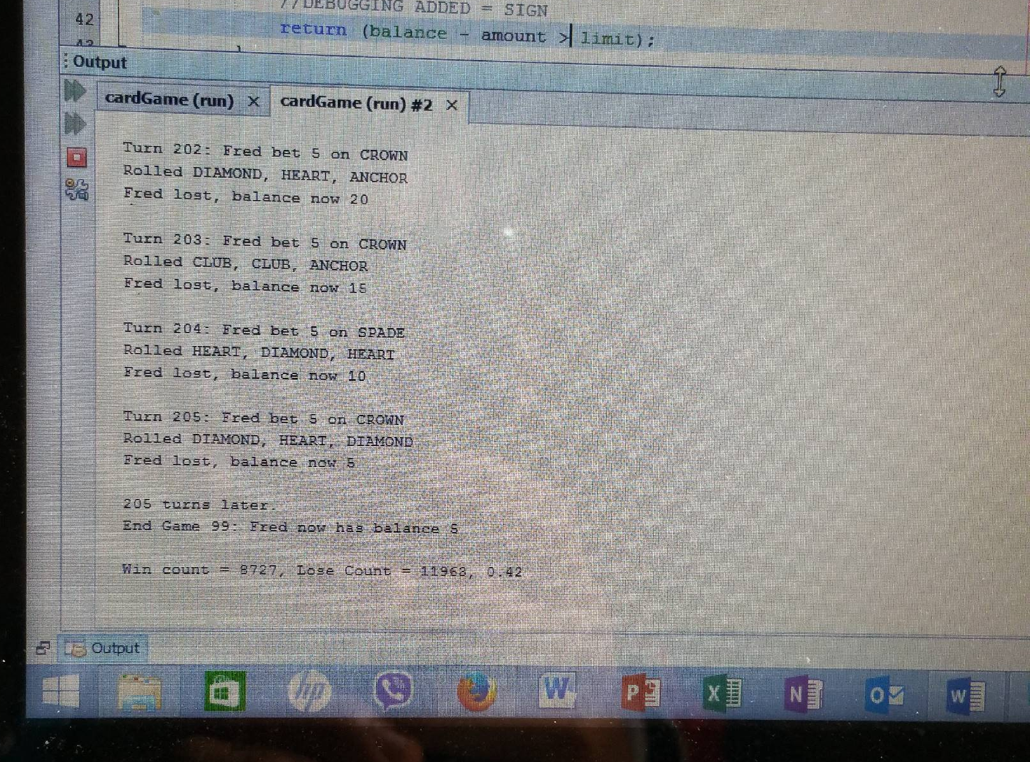
2. balance limit change to zero

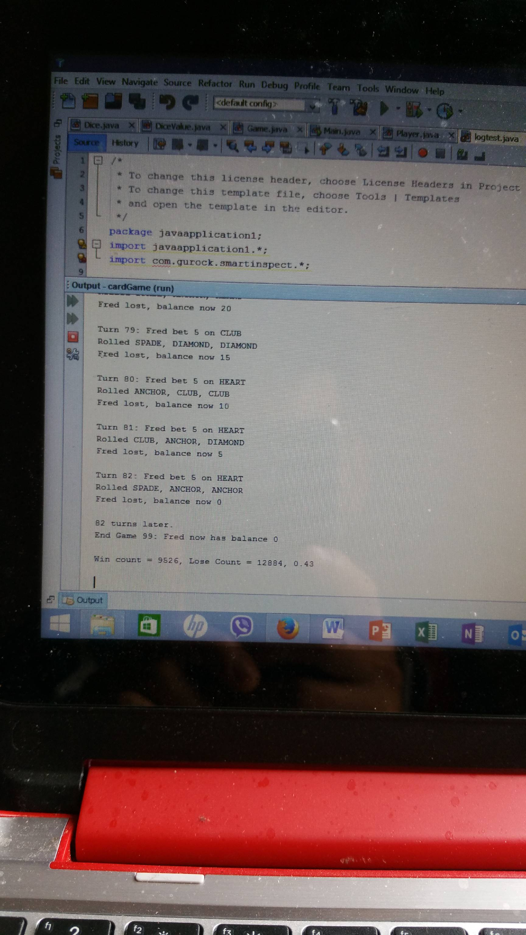

- SAME 3 starting cards after each game
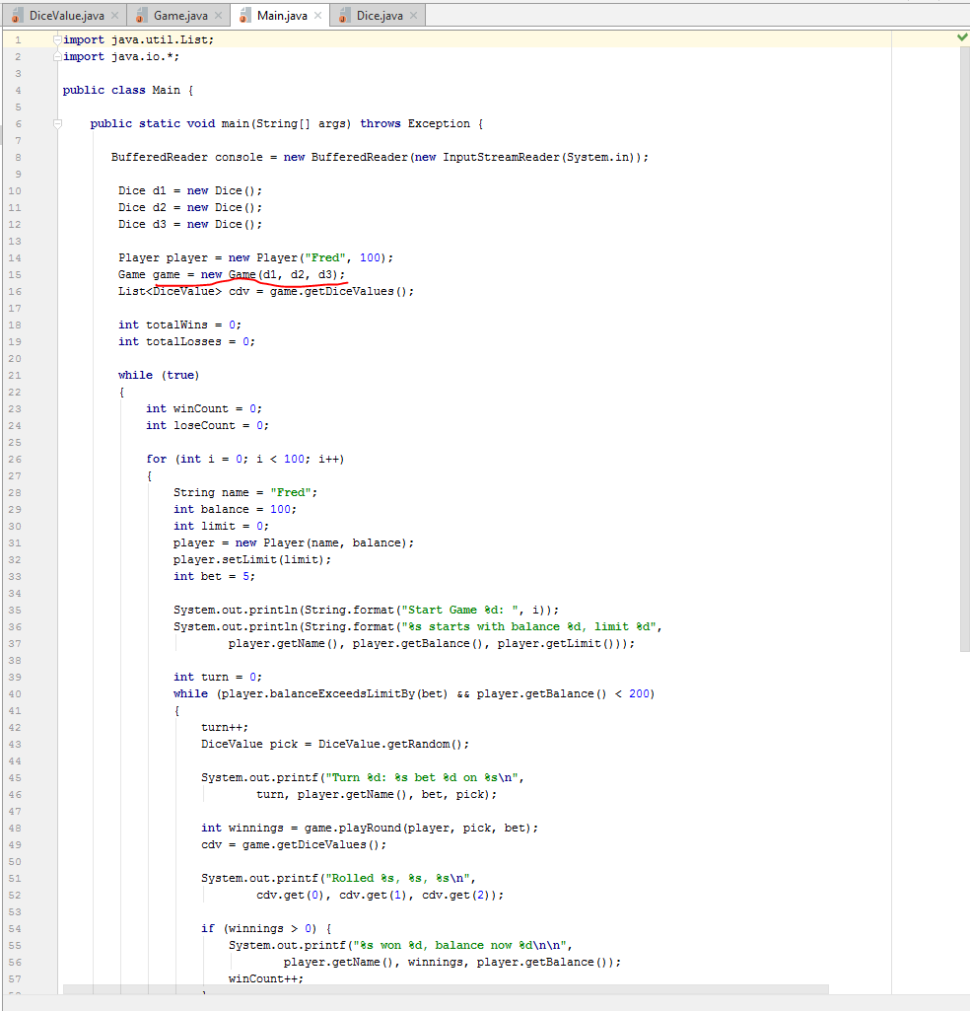

- If player wins, bet amount doesnt take into account
resolved

